ASP’s Tomato Soup

3/3/2025
Full recipe (was more than enough for 7 people). Three onions, 4 carrots, garlic, flour, sugar, honey, ½ & ½. Was very good, but needed more umami. There was a request for hot sauce. Perhaps we throw in a little chile next time?

Grilled cheeses were meh – grilled onions were great, but overcrowded pan to cook many, and pan was not hot enough (shown by lack of toasting on bread, despite pressing and butter, and perhaps indicated by lack of smoking).

5/12/2022
½ recipe, used chicken bone broth (2 cups), half a white onion, no carrots, no garlic. Remembered flour, sugar, honey. Put in a tsp of honey. Could have used 2-3 tsp - much better! Not as good as 3/8/22, but in the same ballpark

4/5/2022
½ recipe, used chicken broth (not bone), red onion, two red carrots, one clove of garlic. Forgot flour. Was not as good as 3/8/2022! Added too much chicken broth. Recommend using bone broth, leaving out garlic see if you can repeat 3/8/2022.

3/22/2022
½ recipe, used beef bone broth, red onion (instead of yellow), added 3 shredded carrots at beginning and 2 cloves of garlic. Left out sugar. Was not nearly as good as previous version!. Blended until smooth. Recommend adding garlic and basil next time and making more watery.

3/8/2022
½ recipe, used chicken bone broth, red onion (instead of yellow), added 2 shredded carrots at beginning. Was so good. Blended until smooth. Recommend adding garlic and basil next time and making more watery.

For grilled cheese– thinner bread, less crusty, shredded cheese works well

2/17/2022
½ recipe, used chicken bone broth, and added 3 shredded carrots at the beginning. Was the best. Need to blend until really smooth, which is hard.

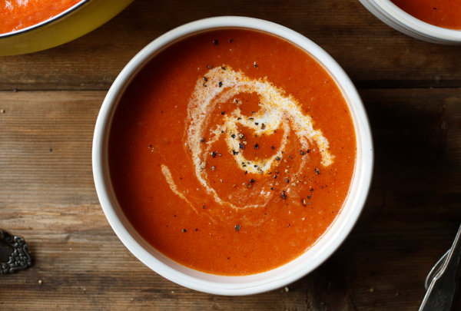

(not our photo!)

INGREDIENTS
- ½ pound butter
- 1 pound onions about 3 medium, cut into 1/4-inch dice
- ½ cup all-purpose flour
- 4 28-ounce cans diced tomatoes
- 1 ¼ cups chicken broth
- ¼ cup sugar
- 1 tablespoon kosher salt
- 1 teaspoon celery salt
- ¾ teaspoon pepper
- ¾ cup half-and-half
- 2 tablespoons honey

PREPARATION
- In a large pot, melt the butter over medium-low heat. Add onions and cook gently, stirring occasionally, until soft and translucent, about 20 minutes.
- Add flour and stir until mixture is slightly thickened and pale gold, about 3 minutes; do not allow to brown.
- Stir in the tomatoes and their juices, chicken broth, sugar, salt, celery salt and pepper. Raise heat to medium until the liquid bubbles, then reduce heat to low. Simmer for 30 minutes, scraping the bottom of the pot frequently.
- Stir in half-and-half and honey. Remove from heat and purée using a hand blender, or allow to cool until no longer steaming and purée in batches in a stand blender. Return to medium heat just until heated through. Serve hot.

